Notice of Race

36th Annual Sail for Hospice

Sunday September 11, 2022

Hosted by the LaSalle Mariner’s Yacht Club (LMYC) LaSalle, Canada

1 Race Rules
1.1 The regatta will be governed by the rules as defined in The Racing Rules of Sailing 2021 – 2024. The Prescriptions of Sail Canada will apply. These can be found at http://www.sailing.ca/
1.2 Sailing Instructions will be posted on the LMYC website and will be available at LMYC clubhouse.
1.3 The Essex County PHRF Class Rules will apply http://ec.phrf.ca/rules.html.
1.4 The Equipment Rules of Sailing shall be used http://www.sailing.org/documents/equipmentrules/index.php
1.5 The Canadian Shipping Act - Small Vessel Regulation (required safely equipment) shall apply - http://laws-lois.justice.gc.ca/eng/regulations/SOR-2010-91
1.6 Yachts shall carry proper sail numbers on mainsails, spinnakers and any head-sails attached having a luff perpendicular exceeding 130%. Yachts without proper sail numbers shall be subject to protest.

2 Eligibility
2.1 This regatta is open to all yachts.

3 Classes, Class pennants & Start Order

3.1 Class Rating Pennant Colour
PHRF Yellow
JAM Green

4 Fees
4.1 There will be a $50 registration fee or $100.00 in pledges. Pledge sheets are available in the L.M.Y.C clubhouse, 2640 Front Road LaSalle, Ontario or on the LMYC website https://lasallemariners.ca

5 Schedule
- 5.1 Sunday September 11, 2022 is the LMYC 36th annual Sail For Hospice. The scheduled time of the first warning signal is 12:55pm.
- 5.2 There will be a skippers meeting scheduled at 12 noon.

6 Registrations
6.1 Eligible boats may enter by completing and signing the attached Registration Form. The completed entry forms, proof of Insurance, along with the entry fee, can be paid at L.M.Y.C. 2640 Front Road, LaSalle, Ontario N9J 2N1 to be in the hands of the Regatta Chairperson no later than 11am Sunday September 11, 2022. Make cheque or money order payable to: LaSalle Mariners Yacht Club. Online registration is possible on the NoticeOfRace.net event website via our website (see sec 16) but please note that currently there is no online payment system for this regatta.

7 Handicap Rules
7.1 As this is a fun race, club ratings will be used for scoring purposes.

8 Venue See Attachment A (Subject to the Province of Ontario’s Rules Governing COVID-19)
8.1 Dockage will be available for competing yachts the evening prior. Limited facilities will be available to travelling yachts.
8.2After the race all are welcome to our club where the flags will be presented, and a fundraising raffle will take place.
8.3 For any U.S. participants, who wish to land, the ARRIVECAN app must be downloaded and completed. Skippers are responsible for making sure they follow the proper customs procedures for their boat and crew. The organizers of this regatta and LMYC are not responsible. The customs telephone number is 1-888-226-7277. LMYC is a designated port of entry.
8.4 All are welcome to join for a BBQ lunch for purchase after the race with all proceeds going to Hospice.

9 The Courses
9.1 The starting area will be in the vicinity of the north end of Fighting Island at between green spar DF27 and the RC boat.
9.2 The courses will be downstream east of Fighting Island and finishing in the general area of L.M.Y.C. The courses and their distances will be described in the Sailing Instructions.

10 Scoring
10.1 In accordance to Rule 89.3(a) Appendix ‘A’ will apply. A boat’s corrected time shall determine her finish position. The Low Point scoring system will then be used.

11 Radio Communications
11.1 Except in an emergency, a boat shall neither make radio transmissions while racing nor receive radio communications not available to all boats. This restriction also applies to mobile telephones.
11.2 The Race Committee will monitor Channel 68.

12 Prizes
12.1 The 1st, 2nd, and 3rd positions within each division will be awarded based on splits determined day of race.
12.2 There will be a flag awarded for th highest fundraising boat.
12.3 There will be a raffle table after the race as a continued fundraiser.

13 Disclaimer of Liability
13.1 Competitors participate in the regatta entirely at their own risk. See Rule 4 of the Racing Rules of Sailing - Decision to Race. The organizing authority will not accept any liability for material damage or personal injury or death sustained in conjunction with or prior to, during, or after the regatta.

14 Insurance
14.1 Each participating boat must carry liability insurance. Proof of Insurance is to be provided as a part of the registration requirements.

15 Customs
15.1 For US participants not landing or mooring, there is no reporting required. For those who wish to land, the ArriveCAN App must be downloaded and completed. Canadian customs must be called as well. Their telephone number is 1-888-226-7277. LMYC is a designated port of entry.

16 Further Information
16.1 Please contact Chris Wysinski (226) 996-9220 or (cwysynski@yahoo.com) for further information.
16.2 The LMYC website: https://lasallemariners.ca (NEW

Thank you.
.

Course Map – See SI’s for details
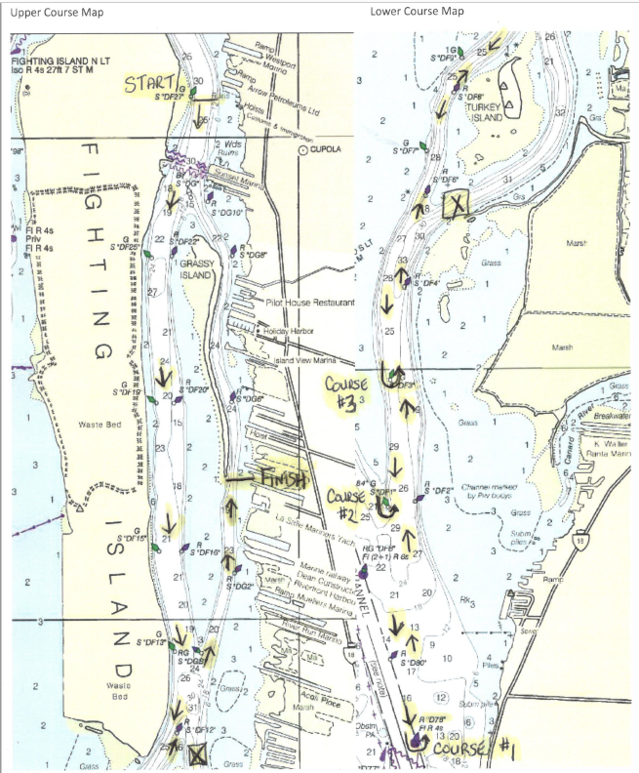

39th Annual Sail for Hospice
Registration Form

CLASS/MAKE OF YACHT _________________________________________

YACHT NAME _________________________________________

SAIL NUMBER _________________________________________

LARGEST HEADSAIL (overlap %) _________________________________________

INSURANCE CO. ________________________________________

POLICY NO. _________________________________________

OWNER (SKIPPER) _________________________________________

ADDRESS _________________________________________

CLUB AFFILIATION _________________________________________

PHONE: BUS._____________________RES.___________________ CELL NO.: _____________________

Competing in:

Spinnaker Division Rating _______ JAM Division Rating _______

E-MAIL ADDRESS______________________________________________________

AGREEMENT TO ASSUME RISKS AND HOLD HARMLESS

In consideration of being permitted to enter this race, all contestants, crewmembers and guests aboard, voluntarily assume the risk of participating in this race and post-race activities. I accept this statement. Please initial here:______

I agree:
(a) to hold harmless against loss, the organization and personnel conducting this race;
(b) to be bound by The Racing Rules of Sailing and by all other rules that govern this event; and,
I certify:
- the yacht is fully insured;
- I have read and accept paragraph 13.1 of this Notice of Race;
- I have read Rule 4 of the Racing Rules of Sailing - Decision to Race.

Owner’s Signature: _______________________________ Date: ________________

The completed and signed entry form, and pledge form to be received by 11am, Sunday September 11, 2022 to:
L.M.Y.C. 2640 Front Road. LaSalle, Ontario N9J 2N1 Make cheque or money order payable to: LaSalle Mariner’s Yacht Club.

