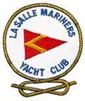
Notice of Race

59th Annual Fighting Island Regatta

Saturday August 27, 2022

Hosted by the La Salle Mariner’s Yacht Club (LMYC) LaSalle, Canada

This is to invite all sailors in and around the Detroit River,

Lake Erie and Lake St Clair area, to participate in our

Annual “Fighting Island Regatta”

We want to acknowledge and thank the volunteers who helped organize this event.

1 Race Rules
1.1 The regatta will be governed by the rules as defined in The Racing Rules of Sailing 2021 – 2024. The Prescriptions of Sail Canada will apply. These can be found at http://www.sailing.ca/
1.2 Sailing Instructions will be posted on the LMYC website and will be available at LMYC clubhouse.
1.3 The Essex County PHRF Class Rules will apply http://ec.phrf.ca/rules.html
1.4 The Equipment Rules of Sailing shall be used http://www.sailing.org/documents/equipmentrules/index.php
1.5 The Canadian Shipping Act - Small Vessel Regulation (required safety equipment) shall apply - http://laws-lois.justice.gc.ca/eng/regulations/SOR-2010-91
1.6 Yachts shall carry proper sail numbers on mainsails, spinnakers and any head-sails attached having a luff perpendicular exceeding 130%. Yachts without proper sail numbers shall be subject to protest.
1.7 Retractable keel shall be down and in a locked position for the duration of the race.

2 Eligibility
2.1 This regatta is open to all yachts that have a valid PHRF Class Certificate, subject to Paragraph 7 - Handicap Rules. To be eligible, all sailboats must be self-righting and not less than 20ft. in length. LMYC reserves the right to refuse any entry.

3 Classes, Class pennants
3.1 Class Rating Pennant Colour
P.H.R.F. A 135 & lower - Yellow
P.H.R.F. B 136 thru 190 - Green
P.H.R.F. C 191 & higher - Orange
J.A.M. - White
Short Handed Class - Pink

3.2 Class flags (not smaller than size 6”x6”) shall be displayed from the backstay at least six feet above the deck. Yachts without a proper flag shall be subject to protest.
3.3 Class splits will be posted by 1900 hrs Friday August 29, 2022 at L.M.Y.C.

4 Fees
4.1 There will be a $30 Registration fee.
4.2 The late fee is $20.00.

5 Schedule
5.1 Saturday August 27th is the Fighting Island Regatta. The scheduled time of the first warning signal is 11:55am.

6 Registrations
6.1 Eligible boats may enter by completing and signing the attached Registration Form. The completed entry forms, a copy of your PHRF rating certificate, proof of Insurance, along with the entry fee, can be sent to L.M.Y.C. 2640 Front Road, LaSalle, Ontario N9J 2N1 to be in the hands of the Regatta Chairperson no later than 1900hr Wednesday August 24, 2022. Make cheque or money order payable to: LaSalle Mariners Yacht Club. Online registration is possible at our website (see sec 16) but please note that at this time there is no online payment system. Your entry fee must still be in by 1900hr August 24, 2022.

7 Handicap Rules
7.1 PHRF certificates that are not issued by the E.C.P.H.R.F. Association will be adjusted to reflect current E.C.P.H.R.F. handicap ratings. Out of date or invalid certificates receive a 10-sec/mile-handicap penalty.

8 Venue See Attachment A
8.1 Dockage and club house facilities will be available for competing yachts the evening prior.
8.2 After the race all are welcome to our club where trophies will be presented and food and refreshments will be served (Nominal charges). Entertainment will be provided.
8.3 All racers are welcome to stay the night and enjoy the club facilities.

9 The Courses
9.1 The starting area will be in the vicinity of the north end of Fighting Island and to the east of the shipping channel.
9.2 The courses will be downstream west of Fighting Island and finishing in the general area of L.M.Y.C. The courses and their distances will be described in the Sailing Instructions.

10 Scoring
10.1 In accordance with Rule 89.3(a) Appendix ‘A’ will apply. A boat’s corrected time shall determine her finish position. The Low Point scoring system will then be used.

11 Radio Communications
11.1 Except in an emergency, a boat shall neither make radio transmissions while racing nor receive radio communications not available to all boats. This restriction also applies to mobile telephones.
11.2 The Race Committee will monitor Channel 68.

12 Prizes
12.1 The 1st, 2nd, and 3rd positions within each division will be awarded flags. If there are less than 5 boats in a division, not all three positions will be awarded.
12.2 The Commodore Alan Moore trophy will be awarded to that boat with the overall best corrected time.
12.3 The Inter Island Trophy will be presented to the boat with the fastest elapsed time.
12.4 This Fighting Island Regatta is a counter towards the ECPHRF Boat of the Year.

13 Disclaimer of Liability
13.1 Competitors participate in the regatta entirely at their own risk. See Rule 4 of the Racing Rules of Sailing - Decision to Race. The organizing authority will not accept any liability for material damage or personal injury or death sustained in conjunction with or prior to, during, or after the regatta.

14 Insurance
14.1 Each participating boat shall be insured with valid third-party liability insurance with a minimum cover of $2 million per incident or the equivalent. Proof of Insurance is to be provided as a part of the registration requirements.

15 Customs
15.1 Skippers are responsible for making sure they follow the proper customs procedures for their boat and crew. The organizers of this regatta and L.M.Y.C. are not responsible. The telephone number is 1-888-226-7277. L.M.Y.C. is a designated port of entry.

16 Further Information
16.1 Please contact the Regatta Chairperson, Bob Reaume at (519) 792-7377 lmycracing@gmail.com for further information.
16.2 The LMYC website: http://www.lasallemariners.ca

NOTICE!!
Please remember that freighters and other large commercial vessels have the right of way. Any participant that interferes with commercial traffic will be disqualified from the race. Once the decision has been made to disqualify a participant, no appeal will be allowed. A stake boat will be monitoring participants in the vicinity of commercial traffic to ensure compliance of the right of way rules. The disqualified boat will be reported to the Race Committee as soon as possible. Your cooperation will affect the entire future of yacht racing on the river. Thank You.

Attachment A
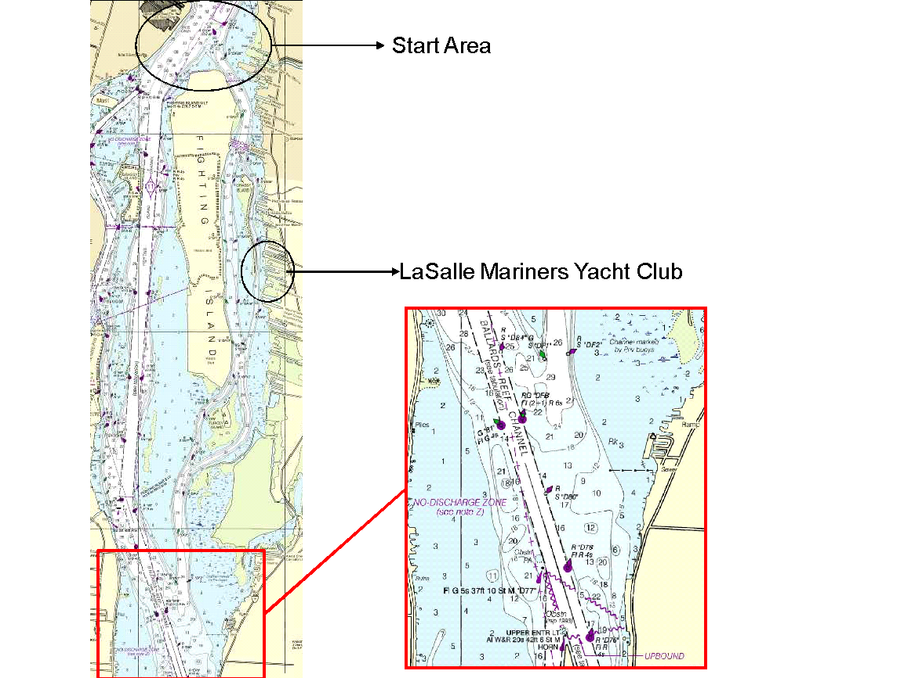

59th Annual LMYC Fighting Island Regatta

CLASS/MAKE OF YACHT _________________________________________

YACHT NAME _________________________________________

SAIL NUMBER _________________________________________

LARGEST HEADSAIL (overlap %) _________________________________________

INSURANCE CO. ________________________________________

POLICY NO. _________________________________________

OWNER (SKIPPER) _________________________________________

ADDRESS _________________________________________

CLUB AFFILIATION _________________________________________

PHONE: BUS._____________________RES.___________________ CELL NO.: _____________________

Competing in:

Spinnaker Division Rating _______ JAM Division Rating _______

Short Handed Division Rating _________

E-MAIL ADDRESS______________________________________________________

AGREEMENT TO ASSUME RISKS AND HOLD HARMLESS

In consideration of being permitted to enter this race, all contestants, crewmembers and guests aboard, voluntarily assume the risk of participating in this race and post-race activities. I accept this statement. Please initial here:______

I agree:
(a) to hold harmless against loss, the organization and personnel conducting this race;
(b) to be bound by The Racing Rules of Sailing and by all other rules that govern this event; and,

I certify:
- the yacht is fully insured;
- I have read and accept paragraph 13.1 of this Notice of Race;
- I have read Rule 4 of the Racing Rules of Sailing - Decision to Race.

Owner’s Signature: _______________________________ Date: ________________

The completed and signed entry form, a copy of the boat’s current PHRF rating
certificate, proof of Insurance and fee, to be received by 1900hr.Wednesday August 24, 2022.
to:
L.M.Y.C. 2640 Front Road. LaSalle, Ontario N9J 2N1 Make cheque or money order payable to: La Salle Mariner’s Yacht Club.

