2022 LMYC Club Racing Sailing Instructions
Monday JOG & Wednesday PHRF Classes

1. Rules
Each race in these series shall be governed by ISAF- RRS, CYA (Canadian prescriptions), except where they are modified by these Sailing Instructions and where modified shall override.
2. Entering and Ratings
2.1 All yachts must be pre-entered before they are allowed to race. This involves filling out an entry form in full, signing the waiver, paying the fees to race that series and submitting said form and fees to the LMYC Race Director. *Fees must be paid by the second week*. Finish times will not be taken for a boat not entered. Entry forms make up page 7 of these instructions. ECPHRF Association ratings/handicaps are used for these series. A copy of the yacht’s current rating certificate or being on the ECPHRF Assoc. Paid up members of ECPHRF are allowed to race the yacht ECPHRF has on file without a rating penalty, except those entering JOG need not be members of ECPHRF to race.
2.2 Invitation: These races are open to members of LMYC and approved non-members alike, provided said non-members are accepted to race by the Race Director.
3. Skippering of Yachts
A person may not skipper another yacht in a race or series in which their own boat is registered in the same class, race or series. Due to the nature of racing in the river only LMYC members may skipper boats in these races (except as noted in “Invitation”)
4. Sail restrictions – for JOG classes only
Sloop rigged yachts sailing in JOG shall not use more than one headsail at time and that sail shall be attached for its entire luff to the forestay in a fractional rig or headstay in a masthead rig. Yachts that are permanently rigged as a cutter may use both jib and staysail provided, they both are attached for their entire length to their respective stays.
5. Race schedule, Race start times
5.1 All JOG (Monday) & PHRF (Wednesday) races shall be sailed in a three-season race schedule, the Spring Series (6 races) starting May16th & 18th through June 20th & 22nd, Summer Series (6 Races) starting June 27th & 29th through Aug 8th & 10th and the Fall Series (6 races) August 15th & 17th through Sept 19th & 21st (1 throw away race in each series). There are no makeup races.
5.2 Starting times: JOG & PHRF (Courses 1 to 6): 18:25 Race Committee boat on station, 18:30 First Horn and JOG A: Yellow Flag raised. This will be signified by 5 horn blasts 1 minute prior to the commencement of the first start sequence.
5.3 Starting times: PHRF (Courses 10 & 11): 18:35 Race Committee boat on station, 18:40 First Horn and PHRF A: Yellow Flag raised. This will be signified by 5 horn blasts 1 minute prior to the commencement of the first start sequence.
5.4 The RC reserves the right to advance the start times based on all participants being in the start area. This will be signified by 5 horn blasts 1 minute prior to the commencement of the first start sequence.
6. Starting
6.1 Races shall be started in accordance with RRS Rule 26.
6.2 Note: Neither Rule 30.1, 30.2 nor 30.3 will be in effect.
6.3 The JOG & PHRF Courses 1 to 6: start line will be between a flag halyard supporting an orange flag on a committee boat anchored at approximately 42 degrees 12 min. N. Latitude, near the East shore of Fighting Island and a floating marker placed approximately perpendicular to the channel, depending on wind direction and at the discretion of the Race Committee, hence known as RC in these instructions. Once positioned at the start line the RC will hoist an Orange Flag. The Orange flag will remain hoisted until the last class has started and cleared the starting area. The RC may remove the starting line 4 minutes after the last start has commenced. See Section 5.2
6.4 The PHRF Courses 10 & 11: start line will be between a flag halyard supporting an orange flag on a committee boat anchored at approximately 42 degrees 10 min. N. Latitude, near the South shore of Turkey Island (DF4). A floating marker placed upriver from DF4 to indicate a Start Box Area. Once positioned at the start line the RC will hoist an Orange Flag. The Orange flag will remain hoisted until the last class has started and cleared the starting area. The RC may remove the starting line 4 minutes after the last start has commenced. See Section 5.2. Any deviation from the new downriver courses to our traditional courses will be announced to all racers prior to the RC departing LMYC by radio and the pink flag flown on the race committee boat.
6.5 Official RC time: the RC will attempt to synchronize their official race timer with the time on their onboard GPS unit and start their start sequence accordingly at 5-minute increments. NOTE: The hoisting of each Class flag signals 5 minutes to that class start and each flag raised or dropped by the RC indicates the RC official timing. Other timing such as horn blasts or GPS time are NOT the official Race Committee time!
6.6 JOG & PHRF Courses 1 to 6: Start Box: Yachts not engaged in their 5-minute start sequence MUST STAY OUT OF START BOX. The start box is defined at one end by the starting line and at the other end by channel markers DF 15 and DF 16, thus creating an imaginary box. Any yacht not in their start sequence that interferes with a yacht starting may be protested and subsequently disqualified. The start box is pictured on the graphical courses page.
6.7 PHRF Start Box Courses 10 & 11: Start Box: Yachts not engaged in their 5-minute start sequence MUST STAY OUT OF START BOX. The start box is defined at one end by the starting line (DF4) and at the other end by our clubs floating orange marker thus creating an imaginary box. Any yacht not in their start sequence that interferes with a yacht starting may be protested and subsequently disqualified.
6.8 Motoring Before the Start: All yachts must turn off their engines prior to the 4-minute prep signal of their start sequence.
6.9 Class flags on RC boat and starting sequence: Class A: Solid yellow flag, Class B: Solid green flag and Class C: Solid orange flag. Race starts are in that order. Classes B and C start sequences begin at the start of the previous class unless delayed or postponed by the RC.
NOTE: In the fall series Class C will start first with B next followed by A.
Note: The “RC’s orange flag” will be flown on the upper mast and class flags flown on the lower yardarms.
Note to class C: Do not confuse the “RC boat on the station flag” (orange flag) with your orange class flag.
7. Committee Boat protection Mark
If the RC boat sets a protection mark, it shall be considered part of the RC boat. Therefore, no yacht may pass between said protection mark and the RC boat. Also, anyone hitting said mark is to have hit the RC boat and must abide by the RRS or face protest and disqualification.
8. Radio Communication
The RC shall always monitor V.H.F. Channel 68. Any announcements from the RC will be made on Ch68. Also, the skipper of a yacht that drops out of a race MUST inform the RC asap, preferably by VHF radio, Ch68. It is each Skipper’s responsibility to ensure their VHF radio is on and in good working order to hear all announcements.
9. Course Display
A number board with the course to be sailed shall be displayed on the RC boat, normally at the bow. These course boards are solid white or yellow with a black number, Courses: 1, 2 ,3, 4, 5, 6, 10 & 11. If only one board is present, then every class sails the same course. If a second board is also present, then A class and B class sail the longer course and C class will sail the shorter course (that is on the second board).
10. The Finish Line
10.1 PHRF Courses: 1 to 6 finish line shall be between Bifurcation marker DGB and the flag on the RC boat, which will be anchored to the East of DGB, unless course is shortened.
10.2 Jog Courses: 1 to 6 finish line shall be between marker DF8 and the flag on the RC boat, unless the course is shortened.
10.3 PHRF Courses 10 & 11: finish line shall be between marker DF8 and the flag on the RC boat, unless course is shortened.

11. Shortening the Course after Start
11.1 The RC may, at their discretion, decide to shorten the course after the start. This could be due to a lack of wind or imminent dangerous weather. The RC, if sensing a possible shortened course, will motor downstream and if choosing to shorten the course they may hoist code flag “S” and give 2 horn blasts. Once they position themselves at a shortened course finish line, they shall hoist a solid blue flag signifying that they are on station at the finish line. The RC boat shall be located on the opposite side of the channel from a marker in the DF channel near Turkey Island. The way to sail the shortened course is to round the bottom mark of a course and sail upstream to the new finish line which the RC, depending on the chosen course, could use DF3, DF4, DF6, DF8, OR DF12 as a shortened course finish line marker, but the RC shall attempt to use DF8 whenever possible. Also, the RC shall attempt to signal a shortened course prior to the first boat rounding the bottom mark and heading up stream. As noted, we will put a yellow strobe light on the RC Tug so that all racers can clearly see the finish line from a distance if the race is shortened.
12. Time Limit
The time limit for each class shall be 2 hours after their start. If no boats in their class finish within the 2-hour limit, the race will be abandoned. If 1 or more boats finish within 2 hours, the race will be recorded for the rest of the class. The committee boat will remain on station for 30 minutes after the first finisher after which they may leave. Any yachts finishing more than 30 minutes after their time limit must take their own finish time and present it to the RC asap so as not to be recorded as DNF.
13. Abandoned Races
If a race is started but not completed due to time limit or abandonment, all yachts that started will be recorded as “DNF”. If The RC chooses to abandon the race, they may hoist the code flag “N” followed by 3 horn blasts. This will signify that the race has been abandoned. The RC may also use their V.H.F. radio to inform the racers of the abandonment.

14. Race postponed on Shore
From time to time, due to the threat of imminent severe and dangerous weather, a race may need to be cancelled. The RC and or RD will attempt to decide by 18:00 the day of the race if they wish to postpone the race. All things will be considered before making this decision. At this time LMYC doesn’t have a suitable messaging system in place to inform skippers so they can inform their crew of the decision to race or not. All skippers and crew should assume the race will take place and should show up at LMYC regardless of weather forecasts. Rain or heavy winds will not be a deciding factor in whether to race or not.

15. Protests
15.1 Protests shall be submitted in writing on a US Sailing/CYA Standard Protest Form only. These forms are available from the race committee or online. Protests must be lodged with the RC within 1 hour of the RC boat returning to her berth. Also, if possible, please notify the RC of your intentions to protest via V.H.F. radio or when crossing the finish line. A Protest Committee will normally hear protests on the next evening of the following day of the race. Protest Notices shall be posted in the Club House within 30 minutes of the RC of when they receive the protest form. This is to inform the parties of the protest when and where a hearing will take place and allows the parties of the protest to gather witnesses if so desired.
16. Alternative penalties
The percentage penalty, Rule 44.3 of RRS (20% of the number of boats entered, with 3 place minimum) or 720 degree turn penalty, Rule 44.2 of RRS apply.
17. Scoring
17.1 Overall series –Not applicable for 2021.
17.2 A yacht may discard 1 race score for the 2021 Series (Spring, Summer & Fall). Ties are broken according to Appendix A8.1
Appendix A9 example: DNS – Did Not Start – points received = 1 point more than # of boats that came to starting area DNF – Did Not Finish – points received = 1 point more than # of boats that came to starting area DSQ – Disqualified – points received = 1 point more than # of boats that came to starting area DNC – Did Not Come to Starting Area – Points received = 1 more point than number of boats registered in that series
17.3 Disqualification: A yacht that has been disqualified by a protest committee in a race must use the race score in which the DSQ happened in her scoring for that series and for the Overall series.
18. Unsportsmanlike Conduct: Our RC are all volunteers. They make mistakes, just like you. Anyone from a boat racing in a series who badgers the RC for an error in the starting sequences, or for any other reason, may be protested, under Rule 69.1 (a) by the RC and subsequently that yacht may be disqualified form that race!

19. JOG & PHRF Course Descriptions (please also refer to graphical race course page)

Course #1: Downstream from the start line leaving the Bifurcation marker “DGB” and Turkey Island to port. Round green spar “DF3” to port. Head upstream leaving Turkey Island to starboard and finish between the bifurcation mark “DGB” to port and the RC boat to starboard. (Handicap Distance 4.46 Nautical Miles)
Course #2: Downstream from the start line leaving the bifurcation mark “DGB” and Turkey Island to port. Round green spar “DF1” to port. Head upstream leaving Turkey Island to starboard and finish between the bifurcation mark “DGB” to port and RC boat to starboard. (Handicap Distance 5.43 Nautical Miles)
Course #3: Downstream from the start line leaving the bifurcation mark “DGB” and Turkey Island to port. Round green spar “DF1” to starboard, red nun “D84” to port, red/green structural buoy “DFB” to port and red spar “DF2” to port. Head upstream leaving Turkey Island to starboard and finish between “DBG” to port and RC boat to starboard. (Handicap Distance 6.37 Nautical Miles)
Course #4: Downstream from start line leaving bifurcation mark “DGB” and Turkey Island to port. Round red spar “DF2” to starboard, red/green structural buoy “DFB” to starboard, red nun “DF 84” to starboard and round “DF1” to port. Head upstream leaving Turkey Island to starboard and finish between the bifurcation mark “DGB” to port and RC boat to starboard. (Handicap Distance 6.37 Nautical Miles)
Course #5: Downstream from start line leaving bifurcation mark “DGB” and Turkey Island to port. Round red spar “DF6” to port. Head upstream leaving Turkey Island to starboard and finish between the bifurcation mark “DGB” to port and RC boat to starboard. (Handicap Distance 2.95 Nautical Miles)
Course #6: Downstream from the start line leaving the bifurcation mark “DGB” and Turkey Island to port. Round red spar “DF2” to port. Head upstream leaving Turkey Island to starboard and finish between the bifurcation mark “DGB” to port and RC boat to starboard. (Handicap Distance 5.43 Nautical Miles)
NEW-PHRF Courses (Downriver) a pink flag indicates Down River starting area being used.
PHRF Course 10 (4 Legs): 6.38 NM – Start DF4, rounding D78 to port, upriver to DF1, rounding to port, return down river to D78 rounding to port, return to finish at DF4 and RC Boat.
PHRF Course 11 (4 Legs): 4.72 NM – Start DF4, rounding D80 to starboard, upriver to D84, rounding to port, return down river to D80 rounding to port, return to finish at DF4 and RC Boat. Be advised that the Bifurcation Mark for the Main Channel and Fighting Island is in between D80 & D84

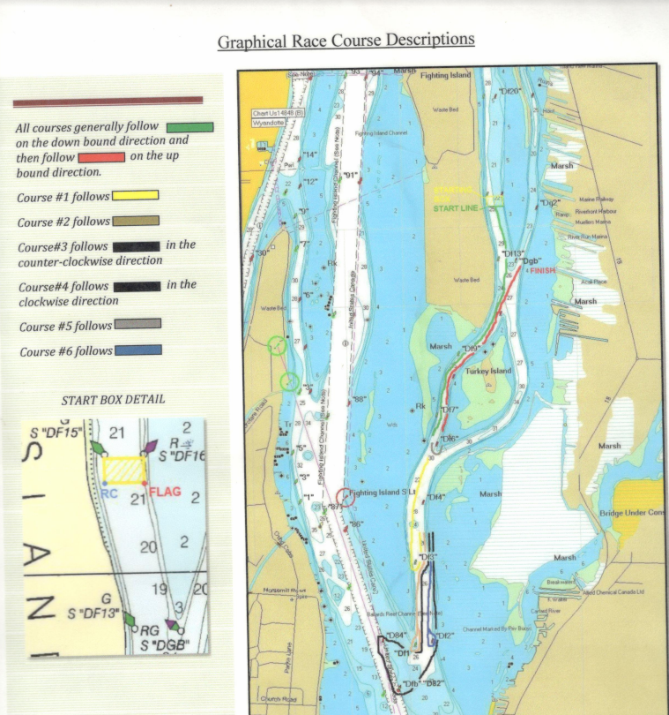

NEW-PHRF Courses (Downriver)
PHRF Course 10 (4 Legs): 6.38 NM – Start DF4, rounding D78 to port, upriver to DF1, rounding to port, return down river to D78 rounding to port, return to finish at DF4 and RC Boat.
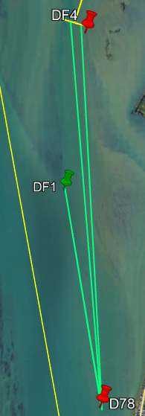
Alternate Finish is at DF8 for the maximum race opportunity of 7.21 NM if RC extends course based on winds.

PHRF Course 11 (4 Legs): 4.72 NM – Start DF4, rounding D80 to starboard, upriver to D84, rounding to port, return down river to D80 rounding to port, return to finish at DF4 and RC Boat. Be advised that the Bifurcation Mark for the Main Channel and Fighting Island is in between D80 & D84
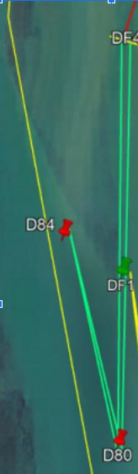
Alternate Finish is at DF8 for the maximum race opportunity of 5.55 NM if RC extends course based on winds.

Check that all safety equipment complies with all regulations, and you are prepared for anything. Have fun and stay safe. Remember, RC monitors VHF 68 or contact Bob’s cell at 519-792-7377 in the event of an emergency.
